Example 4a: Factorial ANOVA Results with Significant Interaction

A 2 X 3 ANOVA was conducted on grade point average improvement with respect to differences in note-taking methods and gender. An alpha level of .05 was utilized for this study. Males and females were normally distributed. Note-taking method was also normally distributed for method 1, method 2, and the control group. Variances were homogeneous, F_{Levene} (5, 54) = .575, p = .719.
There was a statistically significant interaction between gender and note-taking method, F(2, 54) = 10.543, p < .001 (see Figure 1). In order to evaluate the interaction, simple effects were analyzed. There was no statistically significant difference in grade point average improvement for males across note-taking methods F(2, 54) = 2.50, p = .092. A small to moderate effect size was noted, f = .23 (95% CI [0, .54]). There was a statistically significant difference in grade point average improvement for females across note-taking methods F(2, 54) = 25.86, p < .001. A large effect size was noted, f = .93 (95% CI [.62, 1.26]), indicating a strong degree of practical significance and stable finding. In order to investigate the differences in note-taking method among females, a Tukey post hoc analysis was conducted. Method 2 was statistically significantly higher than both the control group (p < .001) and Method 1 (p < .001) (see table 2). Large effect sizes were noted between method 2 and method 1, d = 2.59 and method 2 and control, d = 2.94. A moderate effect size was noted between method 1 and method 2, d = .36. Given the sample size of n = 60, statistical significance would be detected only for large effect sizes, η² > .14.

Figure 1.
Interaction Effect for Gender by Note-taking 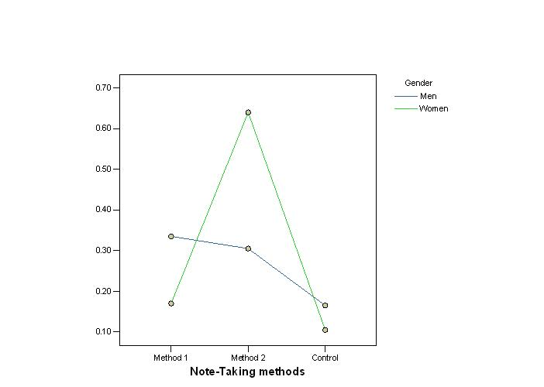

Table 1
Change in GPA Across Gender and Note-Taking Method
Gender | Note-Taking methods | Mean | SD | n
Men | Method 1 | 0.34 | 0.23 | 10
 | Method 2 | 0.31 | 0.19 | 10
 | Control | 0.17 | 0.15 | 10
Women | Method 1 | 0.17 | 0.18 | 10
 | Method 2 | 0.64 | 0.18 | 10
 | Control | 0.11 | 0.15 | 10

Post Hoc Comparisons - gender ✻ method
 |  |  |  | Mean Difference |  | SE |  | t |  | p _{tukey}
Women, Method 1 |  | Women, Method, 2 |  | -0.470 |  | 0.081 |  | -5.789 |  | < .001
 |  | Women, Control |  | 0.065 |  | 0.081 |  | 0.801 |  | 0.966
Women, Method 2 |  | Women, Control |  | 0.535 |  | 0.081 |  | 6.589 |  | < .001
Note. P-value adjusted for comparing a family of 6

